|  |  |
| --- | --- |
| Sales Executive: | Jane O’Connell |
| Sales Office: | 10 Main Road  High Town  Countyshire  AB12 3CD |
|  |  |
|  |  |
| Telephone: | 0123 456789 |
| Website: | [www.hotholidays.com](http://www.hotholidays.com) |
| Email: | [bookings@hotholidays.com](mailto:bookings@hotholidays.com) |

The purpose of this letter is to provide information on our Hot Holiday offers for this year. We pride ourselves in providing a one-stop solution for the holiday-maker, managing all aspects of the holiday package from insurance to excursions, so you only need one point of contact to make your dream break come true. We are a reputed travel agency offering a wide range of travel related services to meet all of the travel needs of our clients.

Please find, enclosed with this letter, our Hot Holiday brochure, which contains information on our travel packages.

Feel free to contact us via email or telephone and we will happy to attend to your queries. We hope to provide you with our travel services soon.

Thanking you,

Jane O’Connell  
Hot Holidays

# Destinations

At Hot Holidays we have selected the best holiday locations in Europe and the Mediterranean. Do look through our brochure and see what inspires your imagination this year.

Whatever destination you choose, one thing is for sure - you will not be disappointed!

## France

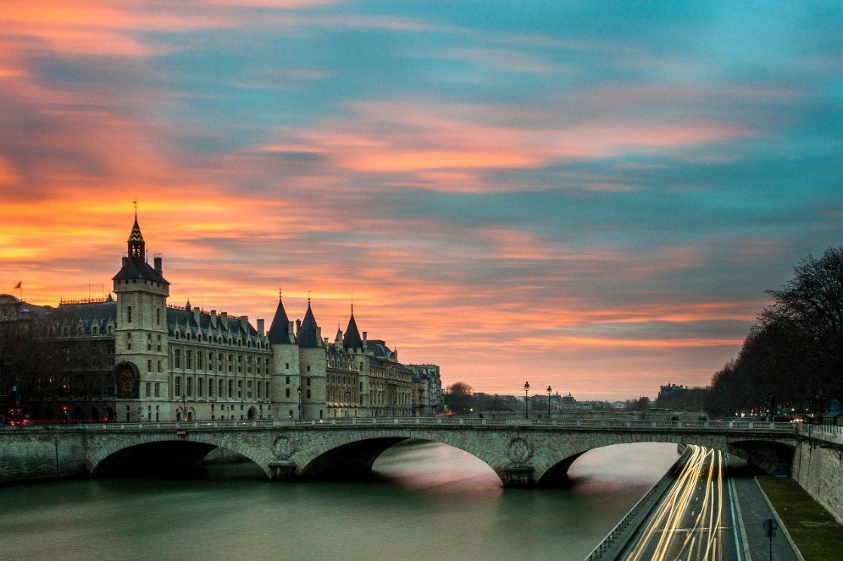

Holidays in France can be all things to everyone. That’s because this beautiful country is as rich in colours, textures and flavours as the sauces it loves to lavish on its famous cuisine.

From romantic Paris to the rolling vineyards of Champagne and vast beaches of Brittany through to the sun-drenched fields of the Loire, glamorous French Riviera and to-die-for Corsica, travelling to France promises to inspire your imagination like nowhere else. You can take breakfast with steaming coffee and flaky, freshly baked croissants on a Paris boulevard. Sip a classic Burgundy on a traditional village square as the locals play boules under the shade of a plane tree. Enjoy extravagant dishes in a cosy Bordeaux cellar. Mingle with the rich and famous around the glitzy marinas and beaches of Cannes or Nice. With our irresistible late deals, bargain holidays and last-minute escapes in France you cannot be disappointed.

## Spain

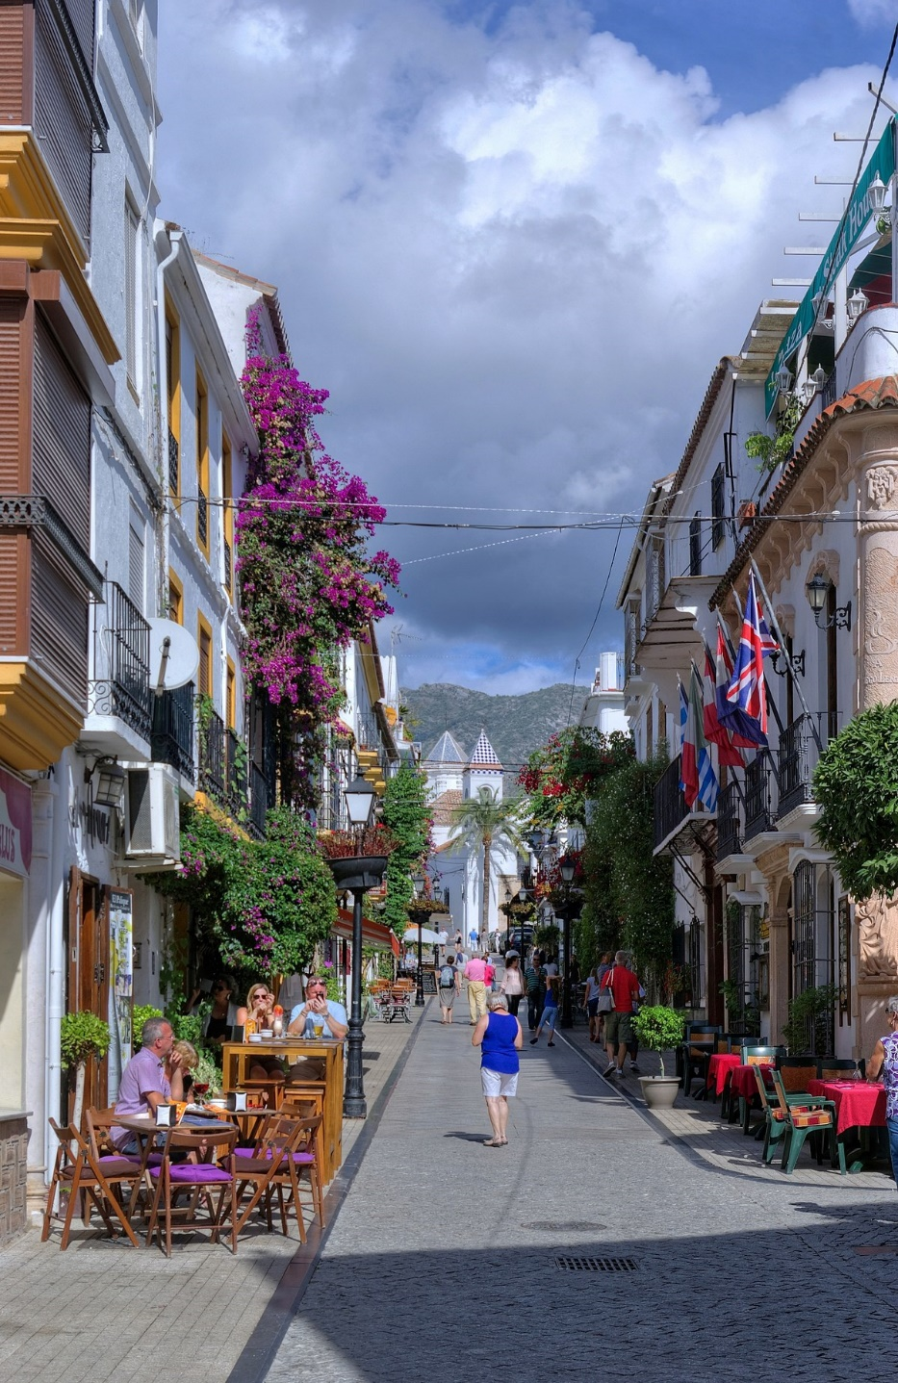

Holidays to Spain aren’t just all about siestas and fiestas, but if you were asked to sum up this colourful country in a nutshell, you can bet these would be high on your list. Along with castanets and the claps of flamenco dancers, of course! They capture the essence of Spain down to a T. Whether you want to discover buzzing cities or are seeking rustic Spain up close and personal, you’ll fall in love with this lively, yet delightfully laid-back country.

When it comes to Spanish holidays on the mainland, you’re spoilt for choice. For drenching yourself in sunshine, the glittering Costa’s are the place to head. From sophisticated and chi Marbella to the shimmering sands of energetic Benidorm you can’t go wrong. Or perhaps it’s to be a cultural quest in Spain’s fascinating cities. Get the best of both worlds in beautiful Alicante slap bang on the coast. Tuck into tasty paella in cosmopolitan Valencia. Or behold the wonders of Gaudi’s Barcelona.

Will it be Majorca or the peace and quiet of pretty Menorca where the stunning scenery is wrapped up in a great big warm welcome? Or maybe it’ll be Ibiza’s legendary nightlife and captivating beaches that’ll get you booking through us.

## Italy

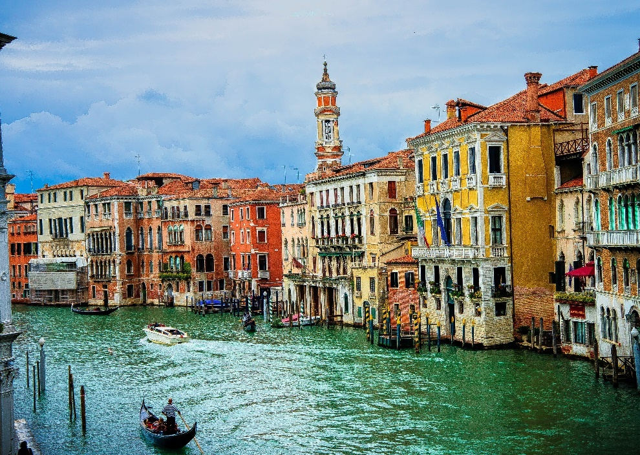

Soul-stirring cities, world famous art, waist-expanding food and wine – holidays to Italy will captivate you from the word go. The only difficulty you’ve got is deciding which slice of this gorgeous country to plump for. Will you take the scenic drive along the breath taking coast, and discover Italian gems like Sorrento? Hike through the breath taking Tuscany countryside en route to Pisa or Florence? Or maybe give the cities a miss and make for the golden sands gilding the Tuscany Coast?

We’ve got the full range of Italy holidays to choose from. And check out our late deals – you’ll be more than just a little temped by our terrific holidays to Italy.

## Greece

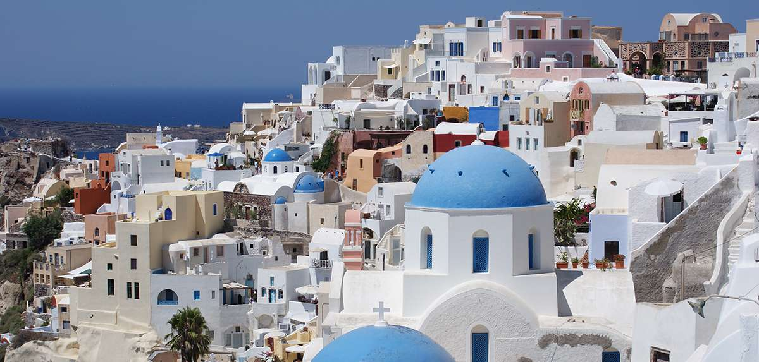

To say you’re going on holiday in Greece doesn’t exactly narrow it down. Are you thinking of a historical journey through Athens or a relaxed beach holiday on one of the islands that are scattered through the Ionian and Aegean Seas? Whatever you’re looking for with a holiday to Greece we can guarantee you’ll find something that’ll take your fancy.

Perhaps you’re looking for a beach holiday with a bit of the ancient mixed in. If so, then a holiday on Skiathos or Zante will suit you down to the ground. From here you can enjoy all the traditional Greek island experiences including fantastic beaches and rustic tavernas. Plus there’s the added bonus of a visit to Athens to see the Acropolis and ruins of the Parthenon to name but a few sites. Does this sound like the first-class holiday to Greece you’re after?

# Holiday Package Offers

See below for our special holiday package offers available for a limited time only. Book now to guarantee your bargain break!

|  |  |  |
| --- | --- | --- |
| Holiday Package | Package Type | Price |
| France – Cannes | 10 days all inclusive | 790.00 per person |
| Italy – Sorrento | 7 days including excursions | 545.00 per person |
| Greece – 5 Island tour | 10 days | 632.00 per person |
| Morocco | 7 days full board plus excursion | 845.00 per person |
| Ski Package | 7 days including passes | 650.00 per person |

# Introduction

Welcome to our new holiday guide. Here you will find information on our holiday offers for this year and how you can find out more details and make a booking. We pride ourselves in providing a one-stop solution for the holiday-maker managing all aspects of the holiday package from insurance to excursions, so you only need one point of contact to make your dream break come true. We have outlined a brief summary of what we can offer below to ensure that you can be confident of enjoying your Hot Holiday experience.

## Flights

All flights are booked through Hot Airways so you can be assured of first-class service on one of our luxury wide bodied jets. You arrive at your destination already relaxed and ready to enjoy your break.

## Hotels

We use only the best 4 or 5-star hotels and guest houses to make sure that you are properly looked after during your stay. All hotels have their own pool and leisure facilities and many have their own private beach ensuring that you have privacy and exclusive service during your holiday.

## ABTA

We are a member of ABTA so you can be assured of the fact that your booking and your payments are guaranteed. You can make your booking at any time confident that your holiday will go ahead.

Please take time to browse and we look forward to welcoming you on one of our magnificent holidays this year.

# Holiday Extras

At Hot Holidays, we believe in providing you with all the additional services you need to enjoy your holiday all in one place.

## Insurance

We are proud to be able to confirm our link with Lorisc Insurance to provide you with competitive rates for your holiday insurance whether it is for this trip or the whole year round. It only takes a few minutes to get a quote on line or by telephone.

See the table below for a price guide.

|  |  |  |  |  |
| --- | --- | --- | --- | --- |
| Policy | Price (per person for 7 days) | Baggage | Emergency | Medical |
| Standard | 15 | ✓ | ✓ |  |
| Elite | 25 | ✓ | ✓ | ✓ |
| Golden (over 50s) | 30 | ✓ | ✓ | ✓ |
| First Class | 35 | ✓ | ✓ | ✓ |

## Car Hire

We have an arrangement with Alpha Car Hire, Europe’s premier car hire agency with offices at airports and ports all over Europe and the Mediterranean. They offer competitive rates and there is a discount for Hot Holiday customers.

You will find our link to Alpha Car Hire on our website booking page and you can book your car at your airport destination to take you on to your hotel. Alternatively, we can arrange for the car to be delivered and collected from your hotel if that is more convenient. We want you to worry less and relax more on your Hot Holiday.

## Currency Exchange

We offer a no-commission currency exchange for all currencies at our European destinations and US dollars too.

You can exchange currency at one of our offices or our terminal locations at the airport. Please state your preference when you book. Exchange rates are competitive as we aim to take advantage of the market conditions so that you get the best deal.

## Excursions

To make your holiday stress free you can plan ahead and book any excursions offered at your holiday destination. Please see the individual brochures for details. Discounts are offered on excursions pre-booked with your holiday.

Many excursions allow the provision of a packed meal for your party included in the price. Please ensure you note this on your booking form.

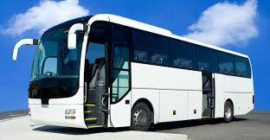

# Hot Holidays, Our Promise to You

Book with confidence… Rest assured that when you book, your Hot Holiday and Hot Airways flight will be ATOL bonded. This means there’s no chance of you being stranded abroad or you losing any money. We’re fully bonded by the Civil Aviation Authority under Air Travel Organisers’ Licence.

Come fly away… We know that not everyone lives close to London, Manchester or Birmingham, which is why we don’t just fly from these airports. With up to 15 UK airports to choose from, you’ll find a great range of holiday destinations with flights from your local airport. But, if you do need to fly from a little further afield, we offer a great range of airport lounges, parking, hotels and more at competitive prices. So leave it with us and we’ll make sure your time at the airport is as enjoyable as possible.

Travel comfortably… We have over 5,000 staff dedicated to getting you there quicker and more comfortably. We’re there to make sure things run as smoothly for you as possible. Whether it’s at the airport, on the flight or finding your transfer bus – we’re here to help. And it’s not just helping to push things along either. Sometimes even the best-laid plans go astray, so if things go wrong, we want to be there to help you get through it.

Flights of fancy… At Hot Airways, we offer more seat space as standard, so you can stretch out in style on your flight. And that’s not all. Travel with us and you can enjoy all sorts of lovely treats. From widescreen seat-back TVs and comfortable leather seats, to four-course meals, we’ve gone all out to make sure you flight with us is as comfortable as possible. But don’t worry, you won’t fork out any extra for these – they’re all included in the holiday price.

Where you lay your head… With over 1,000 hotels and villas, we’re confident we have the right accommodation for you. All-inclusive hotels with the most fabulous beach-front locations. 5 star, top of the range suites in the world’s glitziest cities. Rustic cottages and to die for villas in peaceful, unspoilt locations. We’ve got it all. And at prices to suit every pocket.

# Mailing List

|  |  |  |  |  |  |
| --- | --- | --- | --- | --- | --- |
| **First Name** | **Last Name** | **Address** | **City** | **Code** | **Deposit** |
| Anne | Malkovich | 49 Victoria Road | Sheffield | S88 8KT | 100.00 |
| Carlos | Santos | 145 Windsor Dr. | Wolverhampton | WV30 3NP | 100.00 |
| Tim | Grants | 354 Saw Mill Rd. | Harrow | HA14 3RY | 150.00 |
| Ben | Becker | 87 Country Lane | Bolton | BL77 1RK | 150.00 |
| William | Moore | 561 Third St. | Enfield | EN39 4NE | 175.00 |
| Troy | Magee | 5398 Hollow Rd. | Liverpool | L94 0JN | 100.00 |
| Stacey | Huntley | 86 Creswell Lane | Durham | DH57 0ZN | 150.00 |
| Breanna | Arkin | 6725 Chatsworth Dr. | Ipswich | IP4 3PF | 175.00 |
| Ron | Richmond | 3943 Creekside Dr. | Glasgow | G96 6JX | 200.00 |
| Carol | Olsen | 209 Parrish St. | Dumfries | DG2 2GA | 100.00 |
| Joanne | Hope | 172 Eastland Ave. | Carlisle | CA44 9YU | 150.00 |
| Darcy | Neman | 159 Rutgers St. | Halifax | HX59 1IG | 175.00 |
| Elizabeth | Miko | 23 Pebble Beach Rd. | Warrington | WA31 0QV | 150.00 |
| Michael | Serrano | 1560 Duke St. | Colchester | CO27 7GL | 175.00 |
| Jordan | Shirer | 47 Jean Dr. | Harrow | HA14 3SA | 100.00 |
| Mike | Joyce | 234 Sooner Way | Bolton | BL77 1TD | 175.00 |
| James | Kling | 595 Blossom Rd. | Nottingham | NG90 2ST | 200.00 |
| John | Tai | 3 Church St. | Nottingham | NG90 2DD | 125.00 |
| Karen | Frank | 169 Portsmouth St. | Sheffield | S88 6RD | 100.00 |
| Brandon | Karbharis | 32 Burgundy Lane | Harrow | HA14 3SA | 175.00 |
| Kristin | Laban | 1423 Peachtree Dr. | Liverpool | L94 8UY | 150.00 |
| Lori | Kolari | 127 Gering Ave. | Liverpool | L94 5TR | 100.00 |